DNS TXT Record

📜 What is a DNS TXT Record?
# Source: AI Source: Provided by: [Data Path: Persons Table -> ID Column: 1, Name_En Column: Motasem Essam] -> From: [ChatGPT] on [1/18/2026]
A DNS TXT Record is a type of DNS record used to store arbitrary text information associated with a domain. It’s often used for verification, email security, and other custom purposes.
🧠 Think of TXT records as a way to add notes or instructions to a domain that computers can read.

🔍 Common Uses of TXT Records
# Source: AI Source: Provided by: [Data Path: Persons Table -> ID Column: 1, Name_En Column: Motasem Essam] -> From: [ChatGPT] on [1/18/2026]
- SPF (Sender Policy Framework): Defines which mail servers are allowed to send emails for the domain, helping prevent email spoofing.
- DKIM (DomainKeys Identified Mail): Stores cryptographic keys for email authentication.
- DMARC: Specifies policies for handling emails that fail SPF or DKIM checks.
- Domain Verification: Used by services (Google, Microsoft, etc.) to verify domain ownership.
- General text information: Any other custom data.

🔤 Format Example
# Source: AI Source: Provided by: [Data Path: Persons Table -> ID Column: 1, Name_En Column: Motasem Essam] -> From: [ChatGPT] on [1/18/2026]
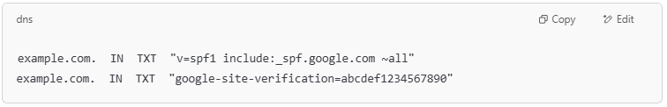
example.com. IN TXT "v=spf1 include:_spf.google.com ~all"
example.com. IN TXT "google-site-verification=abcdef1234567890"

🌐 How TXT Records Work
# Source: AI Source: Provided by: [Data Path: Persons Table -> ID Column: 1, Name_En Column: Motasem Essam] -> From: [ChatGPT] on [1/18/2026]
- When queried, the DNS server returns the text string associated with the domain.
- Applications or services parse the TXT record to verify email legitimacy or domain ownership.

✅ Summary
# Source: AI Source: Provided by: [Data Path: Persons Table -> ID Column: 1, Name_En Column: Motasem Essam] -> From: [ChatGPT] on [1/18/2026]
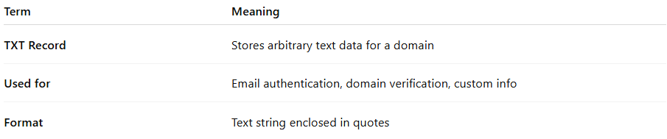
Term | Meaning
TXT Record | Stores arbitrary text data for a domain
Used for | Email authentication, domain verification, custom info
Format | Text string enclosed in quotes

